

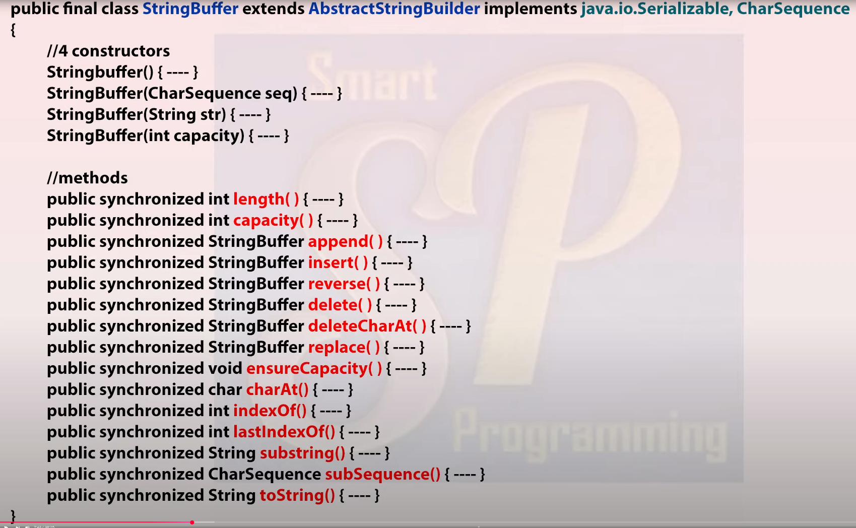

Capacity = 16 initially now you have a string of length l

Now, new capacity of l is (16+l)

But if it exceeds old capacity then new capacity = (old capacity) \* 2 + 2

Append()

Delete(2, 5) 🡪 delete from index 2 till index 4

deleteIndexAt(index) 🡪 Deletes char at index



//false

//true as both the reference variable will be pointing to the same object.

Here equals check if both the reference variable are pointing to the same object or not

But in String class it checks the content of the objects

String s = “abcbca”;

Sb.index(“a”); 🡪 0

Sb.lastIndexOf(“a”); 🡪 5

Sb.insert(index, “abc”) 🡪insert “abc” at index 3

Sb.revesre()